Interface Interspec – Unilab

Triggers - data is being transferred between Interspec and Unilab when:

* A Configuration change happens in IS
* A new specification has been created in IS

Data that is being transferred may be devided into 4 categories:

* Specification data
* User attributes
* Standard attributes
* Group keys

Data that also needs to be interfaced, but currently is passed differently, is frequency data from the control plan.

#### Specification data:

The link between a parameter definition and a parameter profile in Unilab has a number of characteristics. These characteristics are grouped into specification sets (A/B/C).

According to the display format, these values of the properties need to be transferred:

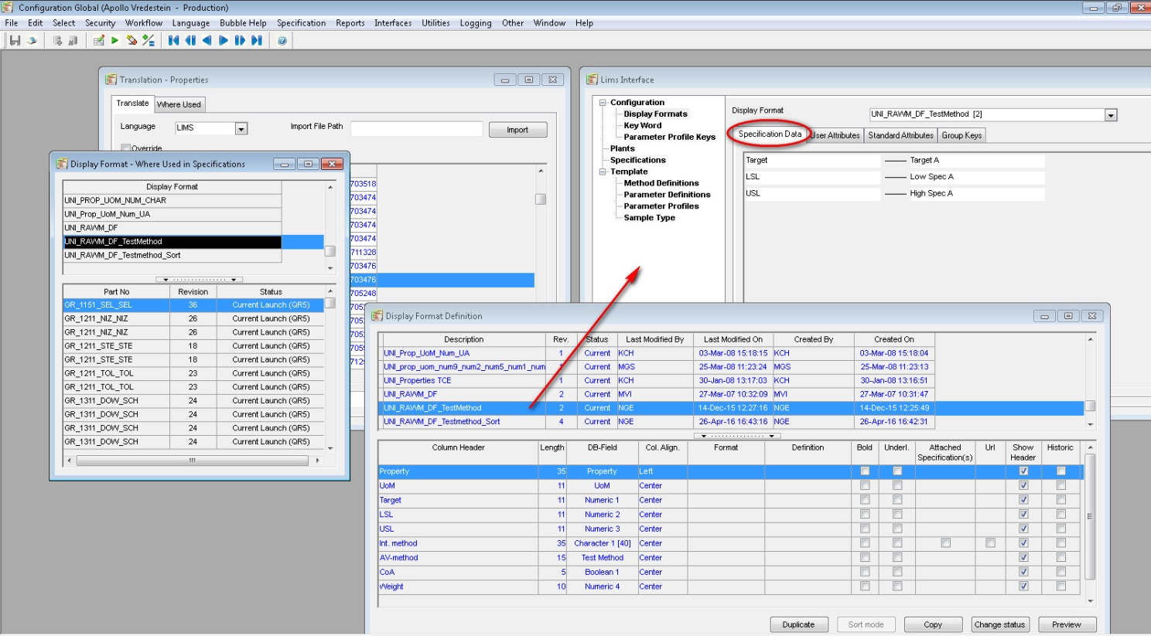

This translates to Unilab:

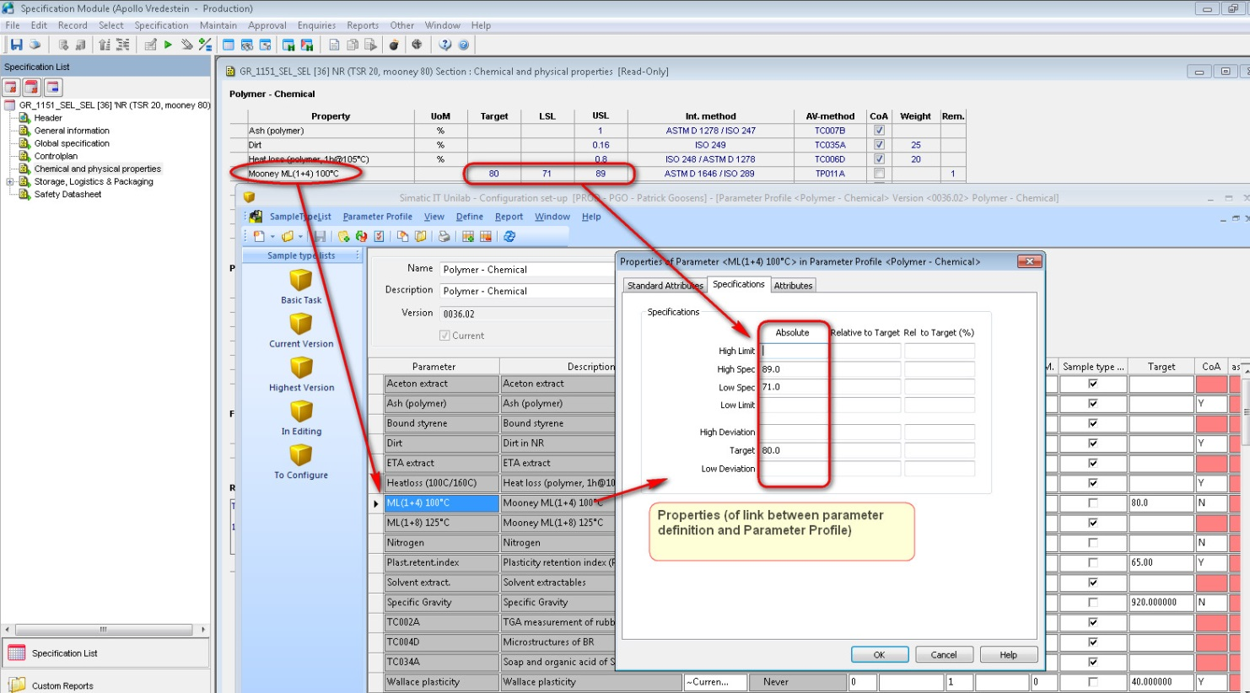

#### User attributes:

User attributes can be configured on two levels:

* Sample type
* The link between a parameter and a parameter profile

Example:

IS Specification: EF_H175/50R16SP5X = Sample type: EF_H175/50R16SP5X

According to the display format, these values of the properties need to be transferred:

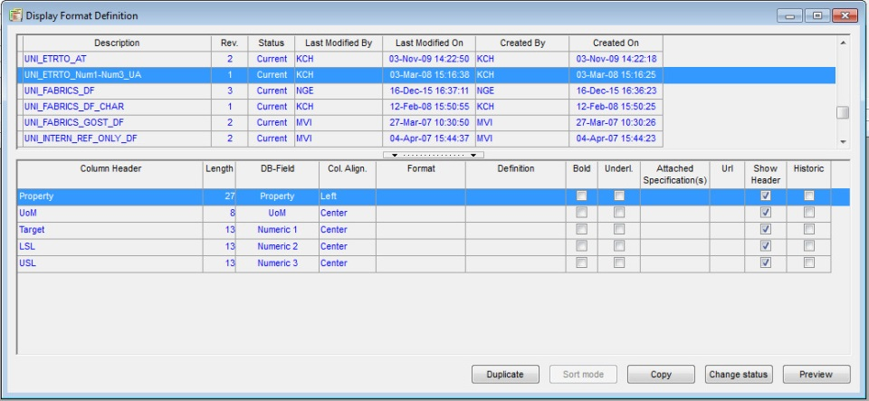

According to the interface definition, these user attributes are mapped accordingly:

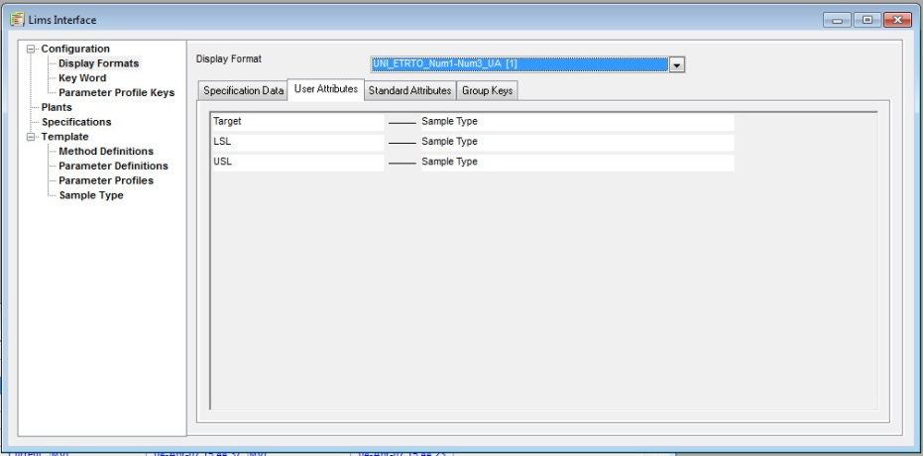

On the Sample type in Unilab these user attributes can be found:

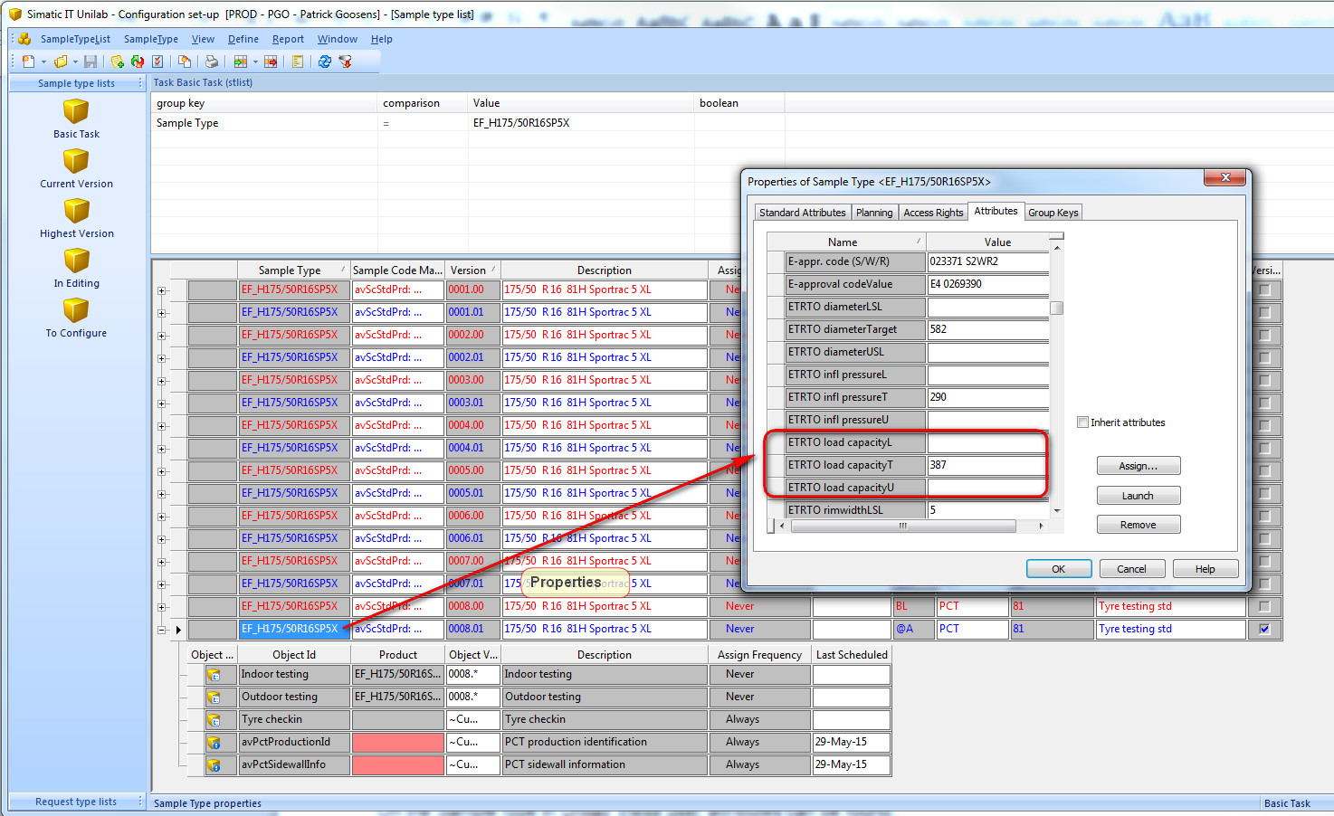

Names of the User attributes in Unilab are concatenated to 20 characters. They consist of the property name (if necessary translated by LIMS language) + the first characters of: Target, USL, LSL etc.

#### Standard attributes:

If I am correct, we are not using this feature to interface standard attributes to Unilab.

#### Group keys:

According to the display format, these values of the properties need to be transferred:  
Hans says: *“I do not exactly know how this works, but I believe you give in the name of a display header column, and if in that display formation you have 10 parameter, you will have this group key assigned 10 times, with the values of the properties. The “property” information is lost in the interface.”*

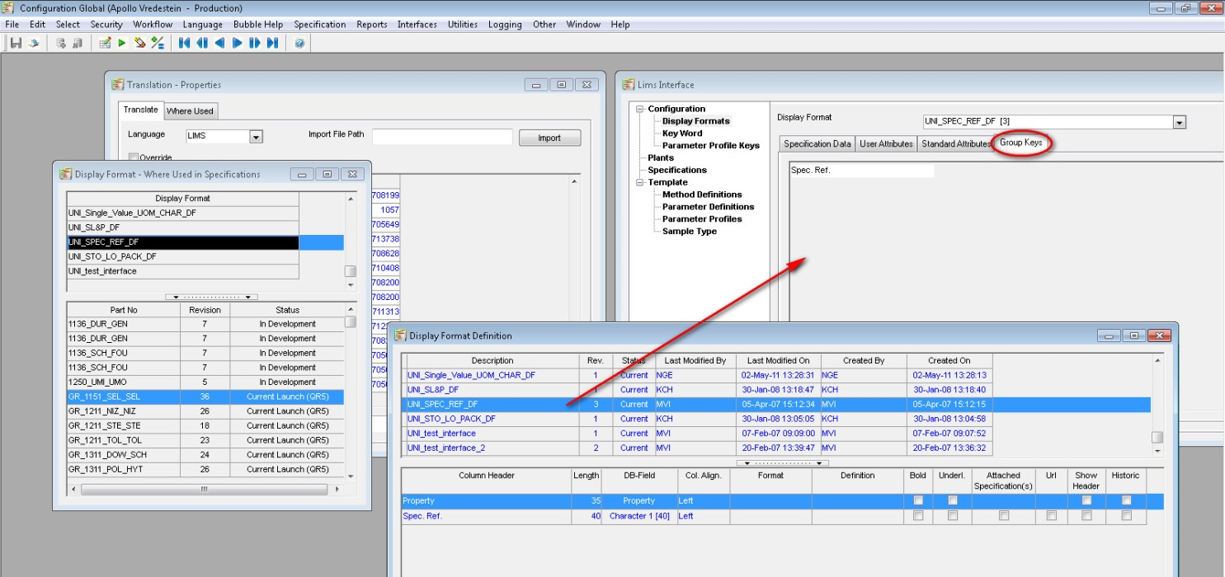

This translate to Unilab:

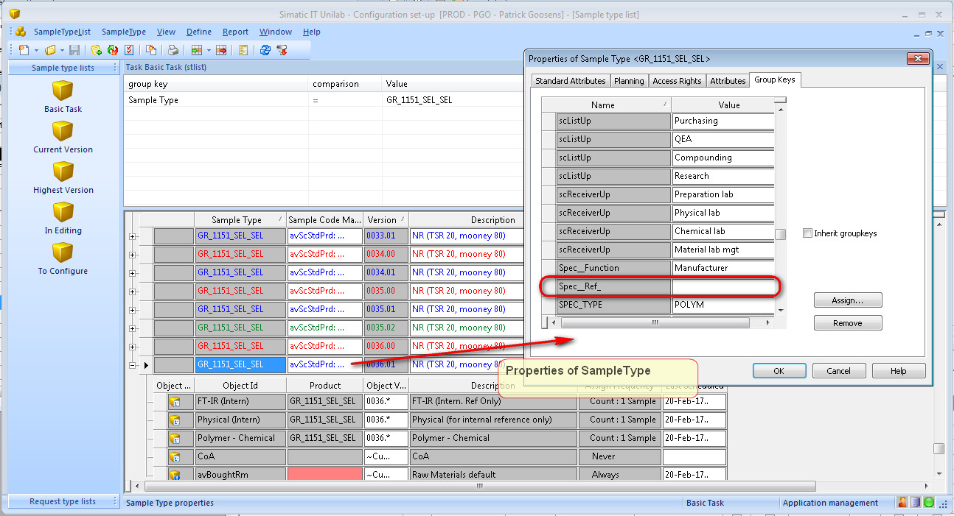

#### Data transfer from Interspec to Unilab:

There are two types of data you can interface to Unilab:

* Configuration data
* Specification data

#### Configuration data exists of:

* Parameter definitions
* Method definitions
* Links between method definitions and parameter definitions
* Sample type groupkey definitions

#### Parameter definitions:

Some considerations:

* A property to be interfaced should belong to a property group
* The ID of the parameter definition is the description in language LIMS of the property (limited to 20 characters). If no LIMS description is found, the normal description is taken.
* It is possible to use a LIMS language per plant.

#### Extra data to be interfaced:

* Control plan information

Control plan holds information for “test” parameters in Unilab

Properties: holds information for “result” parameters in Unilab

#### Properties

From the properties section, properties are linked to Unilab parameters by their names. The name of the Interspec property should match the name of the Unilab parameter (it could be “translated” by using the Lims language).

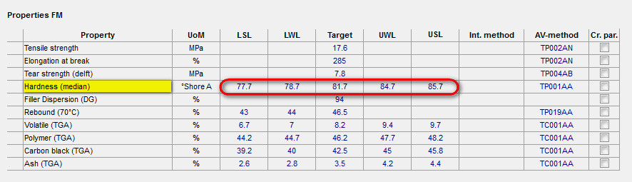

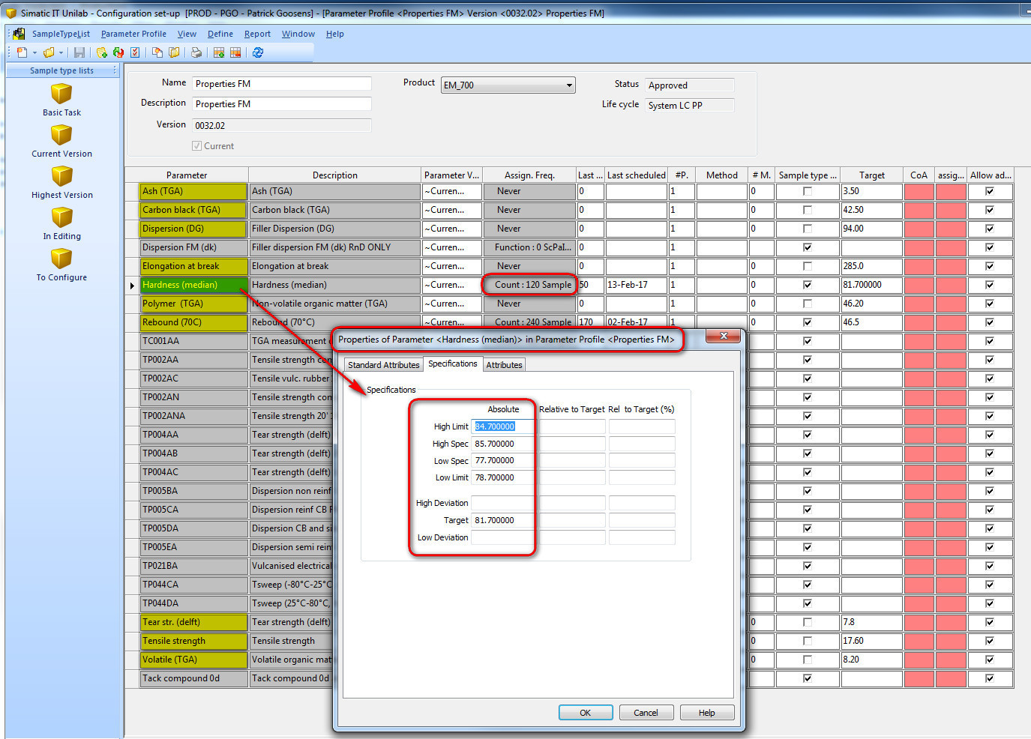

For frequency link (120 Samples) see next page.

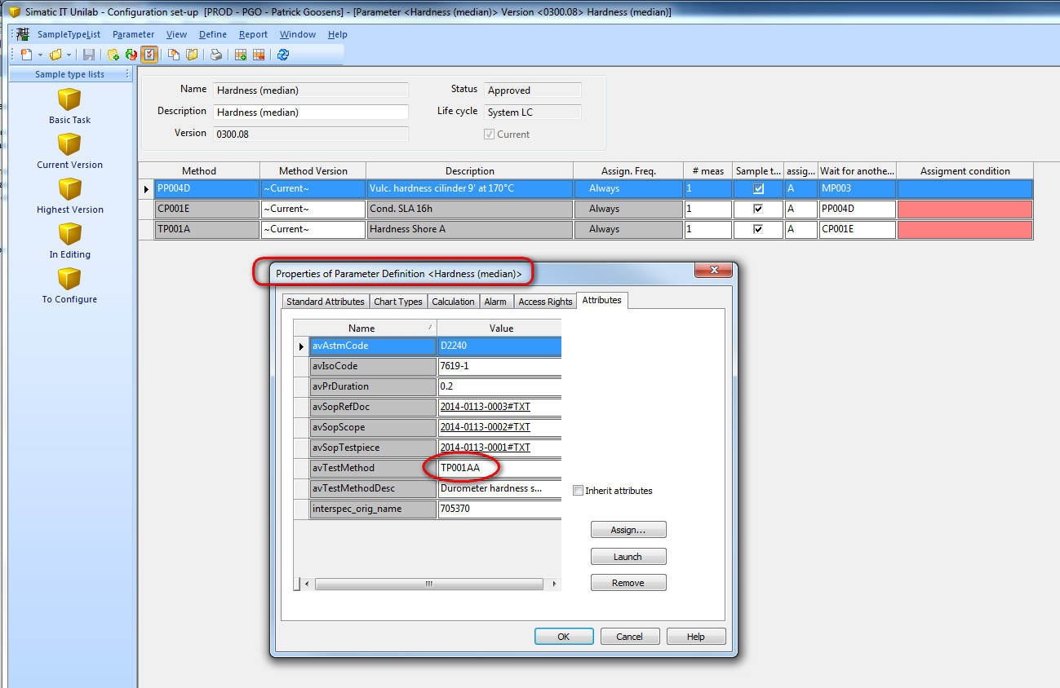

This avTestMethod attribute is linking the parameter to it’s controlplan frequency from Interspec:

#### Controlplan:

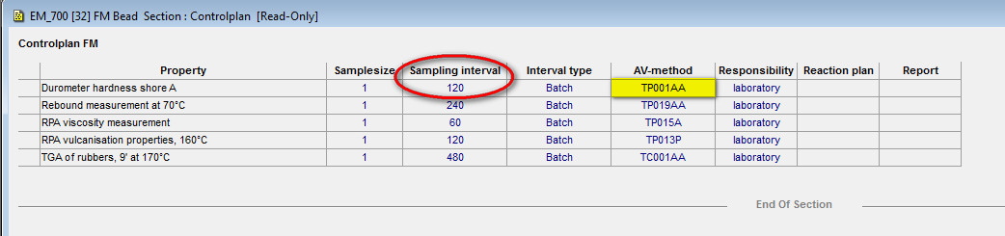

To combine it (again) with the properties, not all controlplan measurements are referring to limits in the properties section:



TC001AA can be found 4x in the properties section, whereas TP015A and TP013P cannot be found. These parameters are created in Unilab because they are part of the SampleType template (in Unilab).

However these 4 TC001AA AV-methods in the property section do NOT refer to parameters in Unilab. The names: “Volatile (TGA)”, “Polymer (TGA)”, “Carbon black (TGA)” and “Ash (TGA)” refer to parameters in Unilab. The limits are also transferred to these parameters in Unilab. But none of these parameters has an avTestMethod attribute, linking them to the control plan. Instead there is a completely different parameter in Unilab (not surprisingly called: TC001AA) which does have an avTestMethod set to TC001AA, linking this parameter to the control plan in Interspec.

Parameter TC001AA is the “test” parameter. It feeds the “result” parameters: “Volatile (TGA)”, “Polymer (TGA)”, “Carbon black (TGA)” and “Ash (TGA)” with measurement data. The “test” parameter refers to the controlplan. The result parameters to the properties.

#### Controlplan interfacing

Unlike “normal” property groups where the display format controls which property groups are interfaced to Unilab and how, controlplan property groups are treated differently.

This propertygroup is not interfaced to Unilab via it’s displayformat. Instead in the LIMS language the “controlplan xxx” property group needs to be translated to “PPPR Frequency” to enable the customisation to “find” the method and extract frequency information from this group (see screenshot).

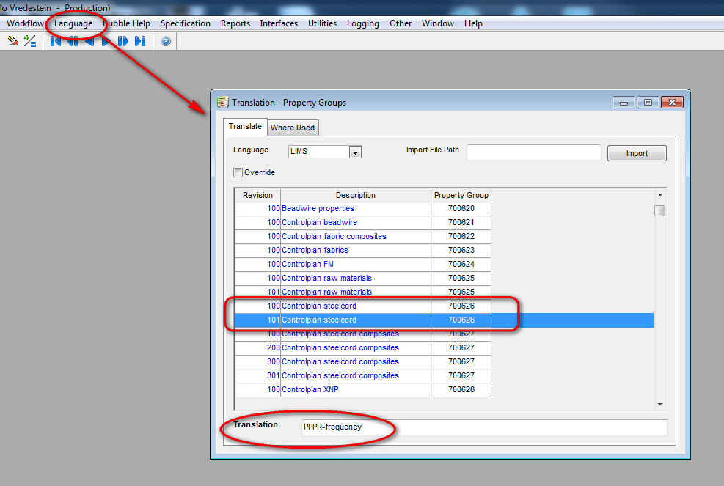

I think there might be an opportunity in the fact that you may have multiple translations of the same controlplan!